Mitigating Deluge: A Resilience Approach for Lumberton, NC
Mostafa Sameer
¹Department of Civil and Environmental Engineering, Florida International University, 10555 W Flagler St, Miami, FL 33174, USA
Email: [msame009@fiu.edu]

Abstract
Floods are one of the most devastating natural disasters, causing significant economic, social, and environmental consequences worldwide. Flood hazard and exposure modeling, coupled with effective mitigation strategies, are crucial for reducing the risk and consequences of floods. The quantification of the hazard modeling approach enhances a risk-informed decision-making process. This study presents a quantitative methodology to evaluate the impacts of flooding at the community level by analytically determining flood levels over a 50-year return period, considering community topology, and subsequently integrating the hazard model with a portfolio of construction archetypes. A systematic methodology was established to allocate the uncertainty related to flood damage throughout all segments of the building for each archetype in the portfolio. This enabled the calculation of total losses that would occur if certain damage thresholds were exceeded, utilizing recognized damage states. The proposed methodology, along with the case study findings, can provide policymakers with a resource for implementing effective preventive measures and mitigation strategies to minimize loss of life and damage to infrastructure and residential properties during flooding occurrences.
Keywords: Flood Risk Assessment; Mitigation Strategies; Community Resilience; Flood Inundation Mapping; Fragility Functions; Flood Loss Estimation; Building Vulnerability.

1. Introduction
Floods rank among the most common and widespread natural disasters, affecting millions worldwide. They are, indeed, the most costly, resulting in considerable loss of life and property destruction, as confirmed by Cigler [1]. Floods can occur due to various factors, including heavy rainfall, snowmelt, storm surges, and river inundation [2].
Flood hazard denotes the probability of a specified flood intensity manifesting at a designated location. Flood risk denotes the probability of harm, destruction, or injury arising from a flood occurrence [3]. The evaluation is affected by various elements, including the likelihood of a flood occurrence, the vulnerability of assets or communities to flooding, and the consequences of the flood event. Flood risk can be reduced by flood risk management measures, encompassing mitigation, preparedness, response, and recovery.
Mitigation is the process of reducing or preventing the risk of flood damage. This may include techniques such as land-use planning, flood-proofing structures, and improving drainage systems [4]. Preparedness entails devising methods and processes to manage a flood event, including early warning systems, evacuation plans, and emergency resources [5]. Response refers to the actions taken during and immediately after a flood disaster to protect individuals, property, and infrastructure. Recovery involves the restoration of infrastructure and services and the physical and psychological rehabilitation of affected communities [6].
Managing flood risk effectively requires a comprehensive and coordinated approach that includes evaluating potential hazards and vulnerabilities, developing and implementing strong mitigation strategies, and preparing for response and recovery from flood events. A plethora of research publications addresses the quantification, evaluation, and alleviation of flood damage. Research focused on the advancement of innovative probabilistic methodologies based on fragilities for quantifying flood risks, hazards, and mitigation encompasses an examination of the impact of building-level flood risk mitigation and adaptation strategies on community-level flood losses [7]; a flood risk assessment analyzing the effects of policy modifications on community-level flood losses [8]; multi-variate and single-variable flood fragility and loss methodologies for structures [9]; and a probabilistic flood loss assessment at the community scale, using the 2016 flooding in Lumberton, North Carolina, as a case study [3]. Further research focused on measuring the economic susceptibility and consequences of natural disasters on communities, including the assessment of economic flood damage [10] and the estimation of the economic impact of natural and social disasters, as demonstrated by Baade et al. [11]. Flood impact studies also focus on assessing structural damage caused by floods, including identifying factors that affect the probability of urban buildings being inundated, using Google Street View, in a case study performed in the Athens metropolitan region, Greece [12].
This paper introduces a methodology for assessing flood damage and loss at both the building and community levels, employing flood fragility functions to propagate uncertainties and evaluate the damage probability of each component based on flood depth and duration, thus determining the exceedance probability of designated damage states for the entire building [8]. The technique employed in a case study of Lumberton, NC, evaluated the effectiveness of diverse mitigation strategies at both the structural and communal levels. The exposure map was generated using ArcGIS, and flood risk was evaluated through a collection of 15 building archetypes that encompass the predominant differences in architectural designs and component configurations. The proposed method eliminates the subjectivity present in current empirical and synthetic damage state functions, allowing for a thorough examination of flood vulnerability in components, structures, and communities, hence supporting objective risk-informed decision-making.

2. Methodology
Flood hazard represents the probability of a given flood occurrence of a certain magnitude transpiring. The consequences depend not only on the incidence of flooding but also on the community's susceptibility and readiness.
The existing depth-damage functions are inadequate in conveying uncertainty throughout the investigation. This research presents a methodology for developing fragilities through system reliability methodologies that evaluate component capacities and configurations to ascertain failure probabilities across different flood depths and durations. The uncertainty concerns the flood susceptibility of particular building elements in relation to flood depth and duration. Specific items are classified as a total loss upon water exposure, including motors (found in washers and dryers), compressors (present in refrigerators, air conditioners, and freezers), and devices holding microchips (such as computers, phones, and printers). Other components demonstrate varying resistance to water and fail at different flood levels and durations. Examples encompass desks, seats, drywalls, and cupboards, which may be entirely or partially replaced depending on the degree of damage incurred. The aforementioned components, albeit prevalent in practically all structures, display heterogeneity in their positions and elevations, hence affecting their susceptibility to flooding. This increases forecast uncertainty and complicates the assessment of buildings' probabilistic performance concerning flood risks. As a result, numerous architectural typologies may exist. Fifteen architectural archetypes developed by Nofal and van de Lindt [9] were employed in the ensuing examination. This enables the integration of various structures with similar characteristics inside each archetype, so ensuring an appropriate representation of the community across the 15 archetypes.
Figure 1 is essential for illustrating the flood risk in Lumberton, NC. It offers a delineation of flood-prone regions predicted on a 50-year return period, a criterion in flood risk evaluation that assesses the probability of a flood transpiring within a 50-year timeframe. The flood hazard map illustrates flood depths around the town, delineating the scope of possible damage. High-risk zones are distinctly delineated, providing essential information for policymakers and urban planners to identify regions necessitating immediate mitigation measures. This map functions as a framework for subsequent study, encompassing the spatial distribution of susceptibility and the prioritization of mitigation strategies.
In practice, these hazard maps facilitate the identification of vulnerable infrastructure, enabling officials to make informed decisions about investments in flood defenses, drainage enhancements, and zoning rules. It is essential to analyze flood hazard data alongside other local geographic information systems (GIS) data, including population density and socioeconomic characteristics, to efficiently identify the most vulnerable regions within the community.

2.1 Flood Hazard Assessment
Flood hazard modeling encompasses the creation of a flood map that specifies water depth at each structure, evaluating exposure to identify vulnerable buildings, and analyzing vulnerability to predict possible damage based on structural attributes and location.
Figure 1 illustrates the hazard map over a 50-year return period, delineating the flood-impacted regions around the city. The state of North Carolina, USA, has an extensive geographic database that includes information on building locations, areas, and first-floor elevations. Nofal and van de Lindt [9] enhanced the evaluation of structural exposure by augmenting the dataset with supplementary attributes such as occupancy type, number of stories, and foundation type.
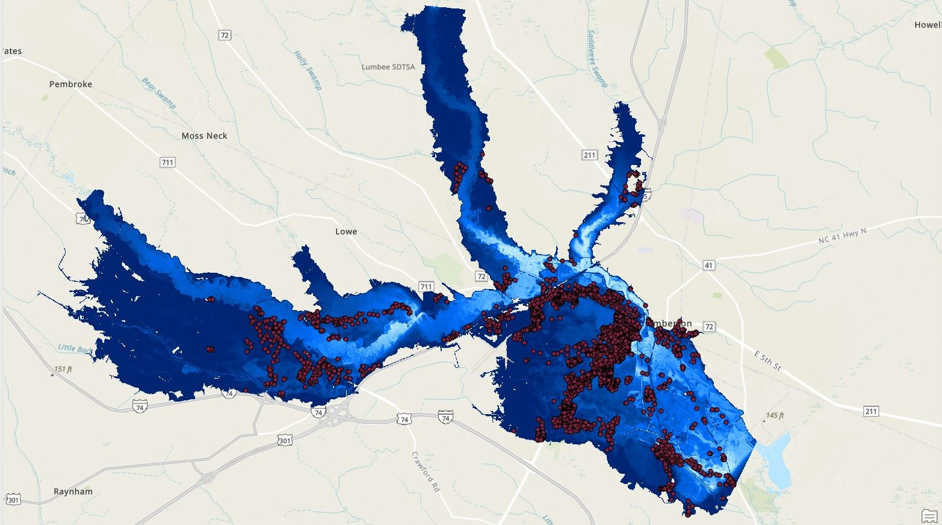
Fig. 1 Flood hazard assessment of buildings under flooding in all damage states (DS)
Figure 2 provides a careful examination of the submerged structures within the study region, emphasizing buildings that encountered floods above their Finished Floor Elevation (FFE). The FFE denotes the elevation of a building's ground floor, a critical element in assessing flood susceptibility. This map delineates structures subjected to substantial water damage by contrasting flood depths with the FFE.
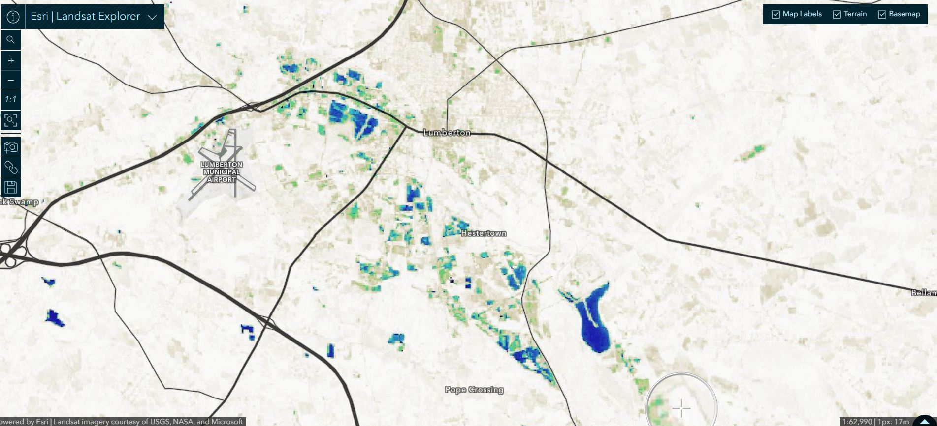
Fig. 2 Damage state conditions of buildings under flood-prone zones of Lumberton, NC

2.2 Flood Exposure Assessment
The hydrodynamic simulation for this project was executed using MATLAB, and the resultant flood depth data were analyzed and shown in ArcGIS. A shapefile comprising the building polygons for Lumberton, with attributes such as building archetype, value, number of floors, and foundation type, was included in the analysis. This integration facilitated the extraction of flood depth measurements for each exposed structure. The flood depth was assessed in relation to the FFE instead of the ground surface level. Figure 3 illustrates the submerged structures inside the community where the flood depth surpassed the FFE. During this 50-year flood event, 321 buildings were identified as inundated.
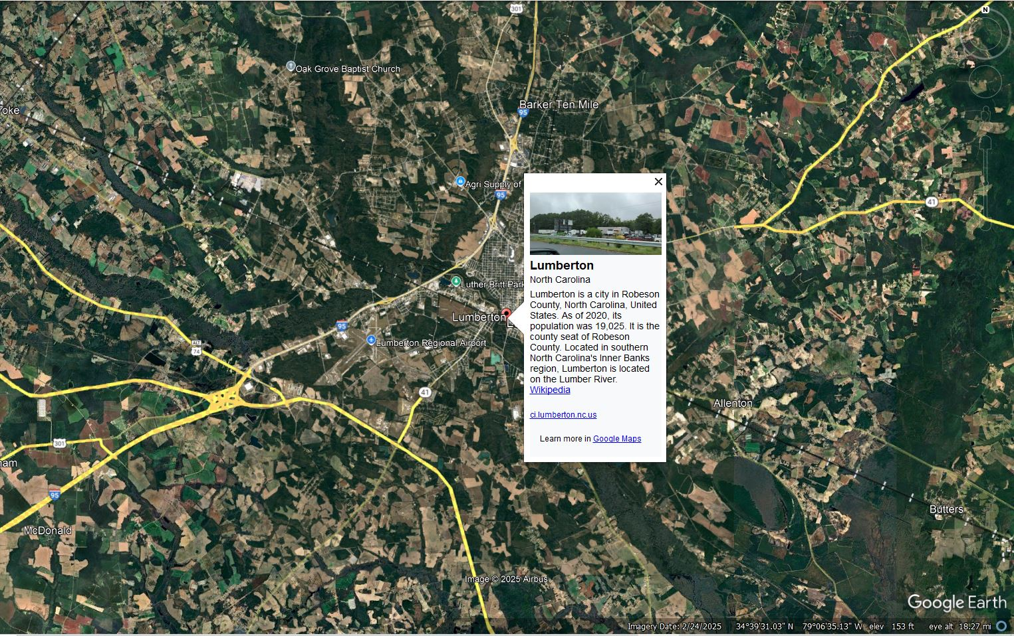
Fig. 3 Google Map view of the Lumber River flowing through Lumberton, NC

2.3 Analysis of Flood Vulnerability
The damage to each structure was evaluated using a vulnerability analysis developed in MATLAB. The shapefile generated from the exposure analysis was imported into MATLAB, accompanied by the fragility parameters and damage depths for each component. The component vulnerabilities were subsequently consolidated according to the weight factor for each component, which is defined as the ratio of the replacement cost of the component to the replacement cost for the particular damage condition. This enables the creation of building-level fragility curves for each archetype under all damage conditions. The percentage loss for each building was calculated by inputting the flood depth above the first-floor elevation into the appropriate fragility function for the specific building typology. The damage was evaluated based on the exceedance likelihood of each damage state (DS), consequently designating a unique DS to each building according to the highest probability of occurrence in each DS, as follows:
L_{f}(IM = x) = Σ^{4i=0} [(P(DS_{i}|IM = x) − P(DS_{i+1}|IM = x)) × Lr_{DSi}]
(1)
The fragility-based flood losses for each building are expressed via:
Bldg_DS(IM = x) = DS_{max} → Max_{i=0..4} [P(DS_{i} | IM=x) − P(DS_{i+1} | IM=x)]
(2)
The total community losses were calculated by summing the losses for all structures. The same method was employed to evaluate the effectiveness of the assessed mitigation techniques compared to the lack of mitigation.
Equation 1 represents the calculation of the total flood loss for a given building, Lf(IM = x), based on the exceedance probability of different damage states (DS). The equation calculates the cumulative flood loss by summing the individual contributions from each damage state DSi, where P(DSi|IM = x) is the probability of the building being in a particular damage state given a specific flood intensity measure (IM). The term LrDSi denotes the loss ratio for that damage state. The difference between the probabilities of consecutive damage states, P(DSi|IM = x) − P(DSi+1|IM = x), is multiplied by the corresponding loss ratio to determine the contribution to total loss from each damage state.
Equation 2 expresses the fragility-based flood losses for each building based on the maximum damage state DSmax that the building could experience, considering different intensities of flood (IM). The equation calculates the total damage for each building by evaluating the exceedance probability of each damage state DSi for flood intensities IM. The fragility function evaluates the probability of the building being in each damage state (from DS0 to DS4) and calculates the total building damage by taking the maximum damage state contribution.

2.4 Mitigation Assessment
Diverse mitigation solutions are utilized to diminish the effects of flooding on edifices and communities. The strategies encompass structural measures including floodwalls, seawalls, floodgates, levees, and evacuation routes, along with policy and planning initiatives such as elevated structures, property buyouts, permanent relocation, zoning, subdivision, and construction codes. Subsequently, the mitigation strategy was evaluated for use at the building level through the installation of flood barriers, pumps, elevation of components, and their combinations. The exposed area was initially evaluated without mitigation to provide a baseline, followed by an analysis of various policy-driven building-level mitigation strategies across different percentages of participating buildings to assess their effectiveness, which is influenced by household cooperation and socioeconomic conditions, including factors that affect the population's readiness to implement these measures.

3. Results
The community's physical environment, including residential, commercial, and social sectors (e.g., schools and hospitals), was categorized into 15 representative building archetypes based on real structures in the U.S. These archetypes were developed to evaluate potential damage to both structural and non-structural components and form the basis for implementing loss functions used to assess economic impacts and recovery needs. Figure 4 illustrates the exceedance probability for each damage state across these archetypes. The case study analysis, conducted using MATLAB, shows how archetypes with crawl spaces (e.g., Archetypes 1 and 3) exhibit minimal damage at low flood depths, while slab-on-grade buildings are more vulnerable. Figure 4(a–o) highlights the varying susceptibility of different archetypes to floods based on their foundation type, number of stories, and material composition, with damage states ranging from DS0 (no damage) to DS4 (destruction).
Assessing vulnerability across diverse building types is critical for understanding the variability of flood impacts in a community. For example, elevated foundations are more resilient at low flood depths, while slab-on-grade buildings are more prone to significant damage. This data guides the selection of appropriate mitigation measures tailored to local conditions. Initially, losses were evaluated without mitigation to establish a baseline. Subsequently, various mitigation strategies were analyzed for their effectiveness in reducing damage and minimizing economic losses. Figure 5 demonstrates the non-linear relationship between flood depth and building loss across archetypes, showing that deeper floods cause exponentially greater damage, especially to electrical systems, HVAC units, and interior finishes. For example, a 1-meter flood significantly impacts crawl space appliances but minimally affects buildings with finished floors above that level. As flood depths exceed 1 meter, the damage intensifies, highlighting the need for flood defenses that account for the unique characteristics of different building types.
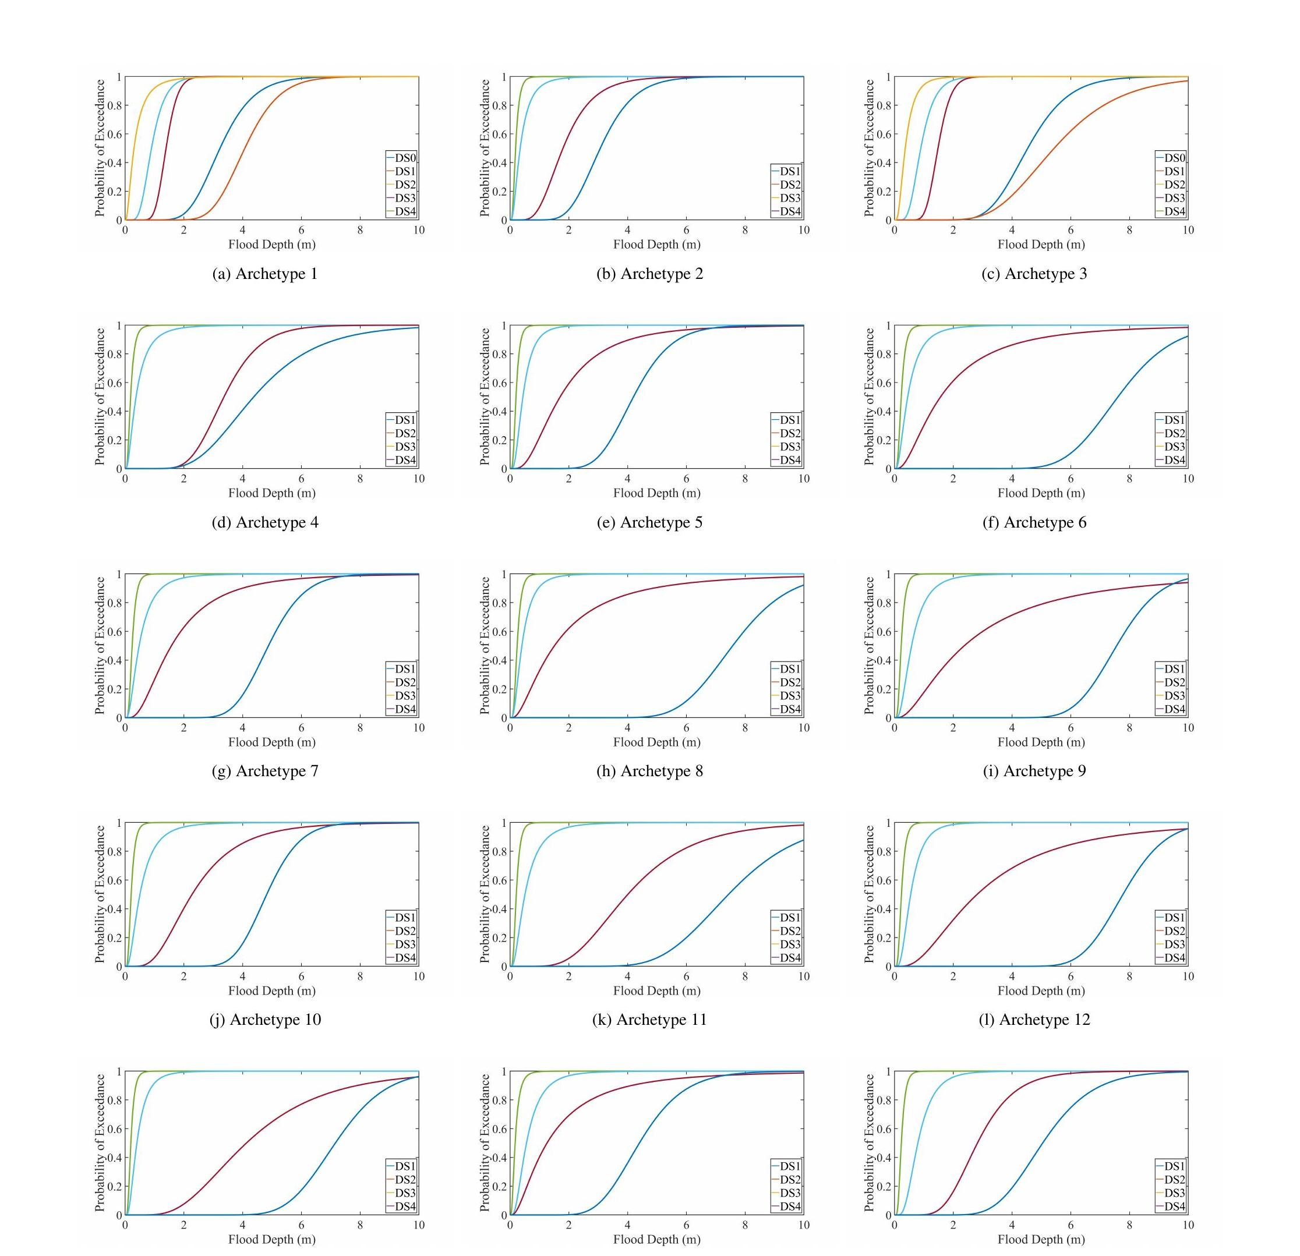
Fig. 4 Damage states for all 15 archetypes: (a) Archetype 1; (b) Archetype 2; (c) Archetype 3; (d) Archetype 4; (e) Archetype 5; (f) Archetype 6; (g) Archetype 7; (h) Archetype 8; (i) Archetype 9; (j) Archetype 10; (k) Archetype 11; (l) Archetype 12; (m) Archetype 13; (n) Archetype 14; (o) Archetype 15
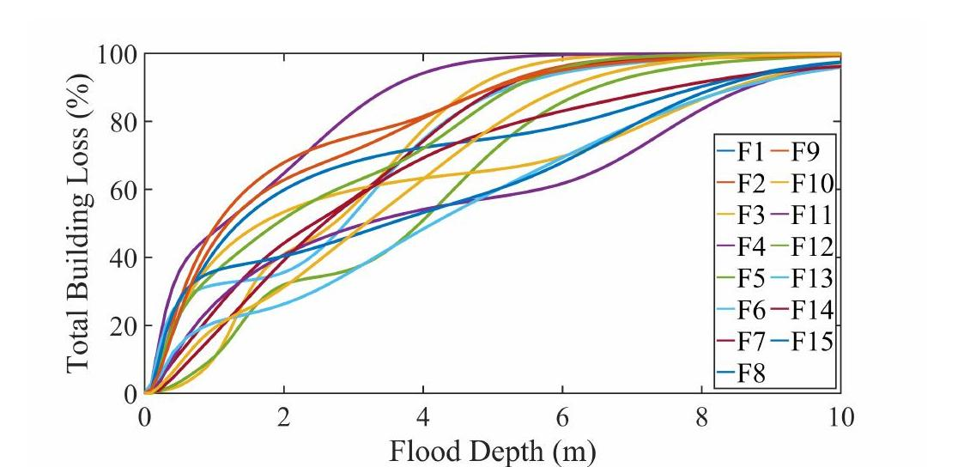
Fig. 5 Total building loss versus flood depth
Figure 6(a–f) evaluates the effectiveness of different flood mitigation techniques, including barriers, pumps, and elevation, both individually and in combination. While flood barriers significantly reduce losses, their adoption across an entire community is unlikely, necessitating partial adoption scenarios. Pumps are effective in reducing flood duration, but only if floodwaters are controlled within a short time frame. If flooding persists beyond 48 hours, pumps become ineffective. Combining multiple mitigation strategies, such as barriers with elevation or pumps, optimizes loss reduction.
Figure 6 demonstrates the cost reduction potential of various mitigation strategies, revealing that flood barriers alone can decrease damages significantly — up to $60 million in a fully adopted scenario. However, assuming full community participation is unrealistic, and partial adoption still yields considerable savings, such as a $100 million reduction with 50% participation.
Figure 6b shows that pumps are most effective when flood duration is limited to one or two days. Beyond this period, the effectiveness diminishes, making pumps impractical for extended floods. With 100% participation, the reduction in losses is limited, emphasizing that pumps alone are insufficient for mitigating long-duration floods.
Figure 6c–f illustrates the combined use of pumps, elevation, and flood barriers. While pumps and elevation significantly reduce losses in the first six days of flooding, the effect wanes after that. The integration of flood barriers and elevation reduces losses over time, and combining all three strategies yields the greatest loss reduction, as shown in Figure 6f.
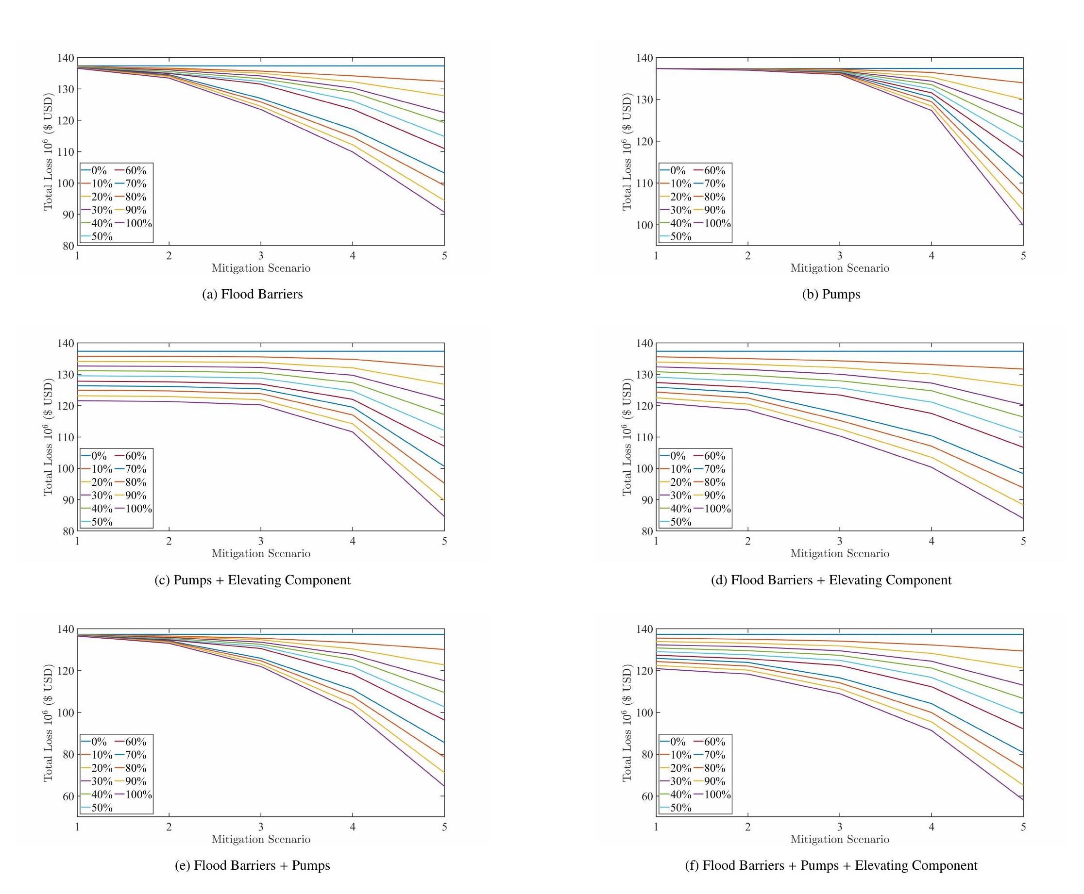
Fig. 6 Comparison between the state of community-level flood losses for different groups of buildings using a number of mitigation scenarios: (a) flood barriers; (b) pumps; (c) pumps + elevating component; (d) flood barriers + elevating component; (e) flood barriers + pumps; (f) flood barriers + pumps + elevating component
The total building loss surface is calculated by summing the replacement costs of damaged components across simulations, providing a stochastic replacement cost for any combination of flood depth and duration. Figure 7a shows a 3D surface for Archetype 3, illustrating the relationship between flood depth, duration, and damage levels. Figure 7(b–f) displays fragility curves for damage states DS0 to DS4. DS0 shows rapid damage escalation even at low flood depths, while DS4 increases gradually with deeper, longer floods.
Figure 7(a–f) displays 3D surface plots illustrating the relationship between flood depth, duration, and exceedance probability. The x-axis represents flood depth in meters, while the y-axis shows flood duration in hours. The z-axis indicates the exceedance probability, reflecting the likelihood of exceeding specific flood levels. As depth and duration increase, so does the probability of extreme floods, with values approaching 1 signifying a likely event.
No matter the duration, very low flood depths have low exceedance risk. More flood depth raises the likelihood of exceedance, even during light floods. At higher flood depths, the surface stabilizes, making a more severe flood almost guaranteed regardless of length. Flood risk assessments depend on these plots to anticipate various flood scenarios, enabling environmental scientists, engineers, and policymakers to make informed decisions on flood prevention, urban development, and emergency response. The link between flood depth, length, and likelihood shows that temporal and spatial elements must be considered when assessing flood risks and preparing for future climate-induced flooding. The sole implementation of flood barriers, pumps, and associated components was found to be the most successful and cost-efficient building-level mitigation strategy.
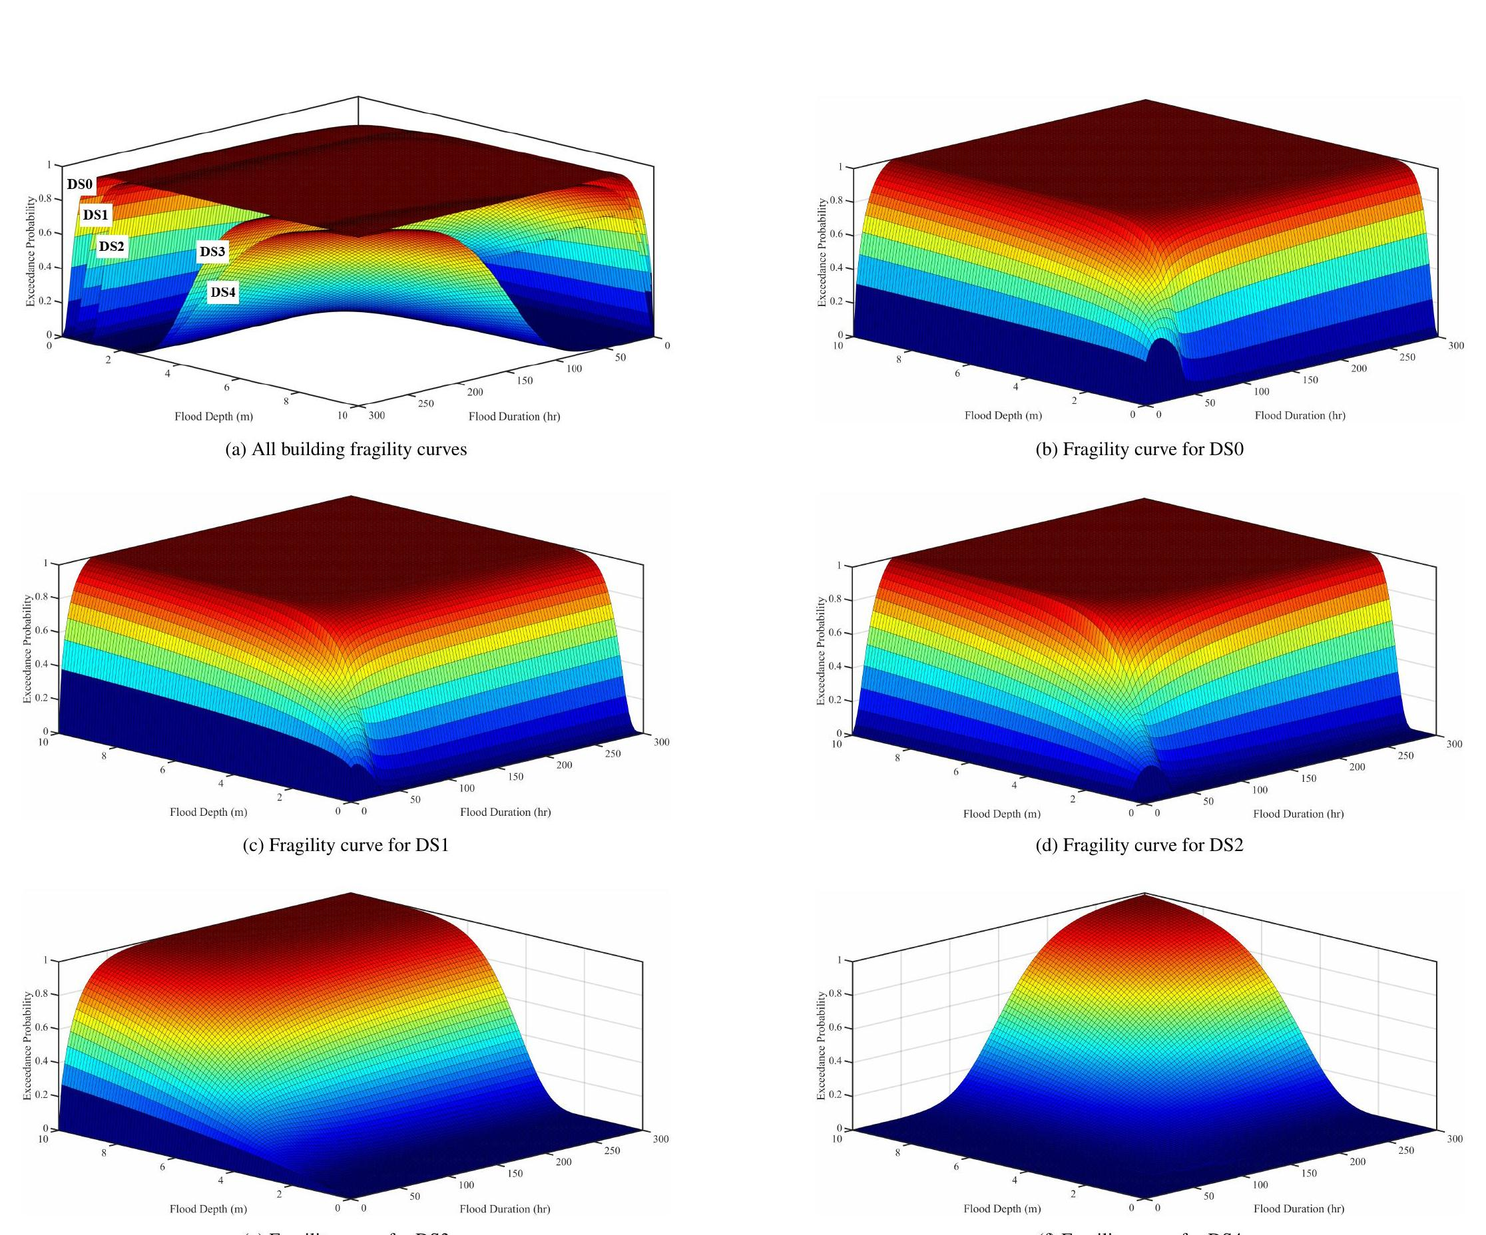
Fig. 7 3-D flood fragility surfaces for the Archetype 3 building in terms of flood depth and duration: (a) all building fragility curves; (b) fragility curve for DS0; (c) fragility curve for DS1; (d) fragility curve for DS2; (e) fragility curve for DS3; (f) fragility curve for DS4

4. Conclusion
Qualitative flood mitigation evaluations have been influenced by subjective elements, including damage assessment team judgment. The probabilistic vulnerability method in this work is more robust and quantitative, incorporating uncertainties about structures' flood depth and duration resistance. This method is better at assessing flood risk since it accounts for both structural and non-structural building components and evaluates how modest building alterations can affect community-level flood damage. The suggested method accurately quantifies flood losses and streamlines the evaluation of various flood mitigation strategies. Using 15 Lumberton, NC building archetypes, the study shows how flood barriers, pumps, and elevated structures operate under different flood scenarios. According to the findings, mitigating techniques must be tailored to each building type and flood scenario. When paired with additional mitigation solutions like raising building components or reinforcing structural parts, flood barriers and pumps can considerably reduce flood damage.
According to the study, integrating mitigating measures, such as pumps, requires thorough cost-benefit analysis. Pumps may be ineffective in the long run if their installation and maintenance costs exceed their flood damage reduction. It is important to evaluate mitigation options as part of a holistic flood risk management strategy. By adding real-time data, behavioral characteristics, and climate change estimates, future studies could improve flood mitigation measures.

Abbreviations
FFE – First Floor Elevation
GIS – Geographic Information System
NC – North Carolina
DS – Damage State
FEMA – Federal Emergency Management Agency

Declarations

Funding
The authors did not receive support from any organization for the submitted work.

Competing interests
The authors declare no competing interests.

Ethics approval
Not applicable. This study did not involve human participants, their data, or biological materials.

Data availability
Data is available from the corresponding author upon reasonable request.

References
[1] Cigler BA. US floods: the necessity of mitigation. State Local Gov Rev. 2017;49(2):127–139.
[2] Merz B, Blöschl G, Vorogushyn S, Dottori F, Aerts JC, Bates P, Bertola M, Kemter M, Kreibich H, Lall U, et al. Causes, impacts and patterns of disastrous river floods. Nat Rev Earth Environ. 2021;2:592–609.
[3] Nofal OM, van de Lindt JW. Probabilistic flood loss assessment at the community scale: case study of 2016 flooding in Lumberton, North Carolina. ASCE-ASME J Risk Uncertain Eng Syst Part A Civ Eng. 2020;6(2):05020001.
[4] Nofal OM, van de Lindt JW. Fragility-based flood risk modeling to quantify the effect of policy change on losses at the community level. Civ Eng Res J. 2021;11:555822.
[5] Kreibich H, Seifert I, Thieken AH, Lindquist E, Wagner K, Merz B. Recent changes in flood preparedness of private households and businesses in Germany. Reg Environ Change. 2011;11:59–71.
[6] Thieken AH, Kreibich H, Müller M, Merz B. Coping with floods: preparedness, response and recovery of flood-affected residents in Germany in 2002. Hydrol Sci J. 2007;52(5):1016–1037.
[7] Nofal OM, van de Lindt JW. High-resolution approach to quantify the impact of building-level flood risk mitigation and adaptation measures on flood losses at the community-level. Int J Disaster Risk Reduct. 2020;51:101903.
[8] Nofal OM, van de Lindt JW. High-resolution flood risk approach to quantify the impact of policy change on flood losses at community-level. Int J Disaster Risk Reduct. 2021;62:102429.
[9] Nofal OM, van de Lindt JW. Minimal building flood fragility and loss function portfolio for resilience analysis at the community level. Water. 2020;12(8):2277.
[10] Merz B, Kreibich H, Schwarze R, Thieken A. Review article "Assessment of economic flood damage". Nat Hazards Earth Syst Sci. 2010;10:1697–1724.
[11] Baade RA, Baumann R, Matheson V. Estimating the economic impact of natural and social disasters, with an application to hurricane Katrina. Urban Stud. 2007;44(11):2061–2076.
[12] Diakakis M, Deligiannakis G, Pallikarakis A, Skordoulis M. Identifying elements that affect the probability of buildings to suffer flooding in urban areas using Google Street View: a case study from Athens metropolitan area in Greece. Int J Disaster Risk Reduct. 2017;22:1–9.

